**Project Design Phase – I**

**Solution Architecture**

|  |  |
| --- | --- |
| Date | 20 October 2022 |
| Team ID | PNT2022TMID05693 |
| Project Name | Smart Waste Management System For Metropolitan Cities |
| Maximum Marks | 4 Marks |

**Technical Architecture:**

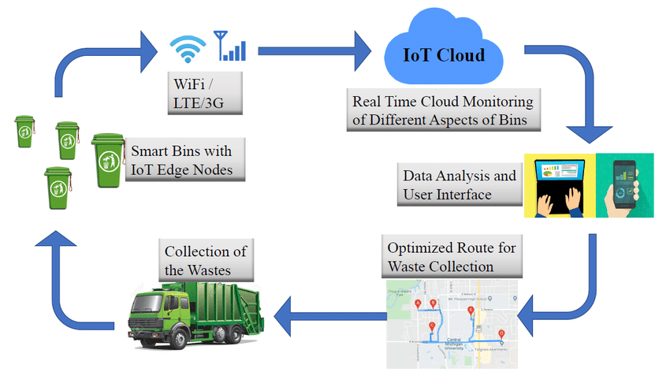

**Table 1: Components & Technologies**

|  |  |  |
| --- | --- | --- |
| **S.No** | **Components** | **Description** |
| 1 | Wi-Fi Module | It gives you the capability to control your devices and collect data from IoT devices safely and securely no matter where we are. |
| 2 | Ultrasonic Sensor HC-SR04 (Generic) | Ultrasonic Sensor HC-SR04 is a sensor that can measure distance. It emits an ultrasound at 40 000 Hz (40kHz |
| 3 | Arduino UNO | Arduino UNO is a low-cost, flexible, and easy-to-use programmable open-source microcontroller board that can be integrated into a variety of electronic projects. |
| 4 | Jumper Wires (Generic) | A jump wire is an electrical wire, or group of them in a cable, with a connector or pin at each end, which is normally used to interconnect the components of a breadboard without soldering. |
| 5 | Cloud Server(IBM) | Application deployment on Local System/Cloud. |
| 6 | Cloud Database | Database Service on Cloud. |
| 7 | User Interface | How user interacts with application to alert the track driver |
| 8 | Arduino IDE | It contains a text editor for writing code, a message area, a text console, a toolbar with buttons for common functions and a series of menus. It connects to the Arduino hardware to upload programs and communicate with them. |

**Table 2:Application Characteristics**

|  |  |  |
| --- | --- | --- |
| **S.No** | **Characteristics** | **Description** |
| 1 | Open-Source Microcontroller | Arduino UNO is used to make the IoT Device |
| 2 | Security | Encryption/Decryption used for security purpose |
| 3 | Scalable Architecture | New feature can be added |
| 4 | Availability | Web application can be accessed from anywhere |
| 5 | Performance | All truck drivers can access the application at same time |